Kevin McMahon
11-20-2025

Module 5 Deliverable
Visualization Tools Proposal

CIS4836CCBE Section 01CBE Web Analytics

Evelyn Zayas


To: LFC Dashboard Project Team
From: Kevin McMahon, Independent Consultant
Subject: Proposal for Data Visualization Tools and Financial Dashboard Guidance
Date: 11/16/2025

Introduction
This proposal provides guidance on the use of visualization tools and a recommended approach for creating a financial dashboard for Legacy Financial Consultants. The goal is to help the team present market data and client performance insights in a way that is practical and accurate for decision making. Clear data visualization turns large amounts of information into something that clients can understand. When financial trends are presented visually, decision makers can notice changes that might be missed in long tables or written summaries.

Importance of Clear Data Visualization
Financial data often involves movement over time, comparisons across market sectors, and shifts based on economic conditions. When data is presented visually, it gives clients a faster way to process patterns and changes. Well designed visuals can help answer questions like whether a client’s portfolio is outpacing the market or whether interest rate changes are affecting specific asset groups. Visual clarity lowers the chance of misinterpretation and supports better financial decisions.
Dashboards can also guide conversations during client reviews. Instead of reading through complex spreadsheets, a financial advisor can use a line chart to highlight the growth of a retirement account or a bar chart to compare how different holdings performed in the last quarter.

Chart Types for Financial Metrics
Different types of financial insights call for different data visuals. The dashboard should include a mix of charts that fit the purpose of each metric. The following chart types are recommended:
Chart Type | Purpose in Financial Analysis | Example Use
Line Chart | Shows changes over time | Daily or monthly performance of an index or portfolio
Bar or Column Chart | Compares values across categories | Asset allocation by sector or region
Pie Chart | Displays parts of a whole | Portfolio composition by fund type
Scatter Plot | Shows relationships between variables | Risk and return comparison for different assets
Heat Map | Highlights variations and market movement | Market sector performance changes across days or weeks

Choosing the correct visual format supports clarity. For example, portfolio managers usually rely on line charts to show trends because they reveal rises and dips in performance. A pie chart may be used when meeting with clients who want a simplified view of how their money is distributed among stocks, bonds, and cash positions.

Best Practices for Financial Data Visualization
Effective dashboard design requires a few guiding practices:
- Simple visual structure so clients can focus on the meaning of the data without extra distractions.
- Consistent color usage so that similar categories are easy to identify across multiple charts.
- Readable labels and titles placed where the audience can understand what they are viewing without guessing.
- Context and comparison points such as historical averages or last quarter’s values so that viewers understand why changes matter.
- Guided flow of information, placing the most important metrics near the top since most readers view top to bottom.
These practices keep the dashboard from feeling crowded. The focus should always stay on financial insight, not decoration.

Public Sources of Financial Data
The following sources offer credible and publicly available financial information:
Source | Type of Data Available
Yahoo Finance | Stock prices, fund performance, news, and analyst insights
U.S. Bureau of Economic Analysis | Economic indicators, GDP, consumer spending data
Federal Reserve Economic Data (FRED) | Interest rates, inflation, money supply, and banking metrics
Investing.com | Market charts, commodities, currencies, and futures

These resources give the firm access to economic and market data without the need to build custom collections from scratch.

Automated Data Mining vs Manual Collection
Automated data mining provides the firm with a faster and more reliable way to collect financial information. A manual process takes more time, increases the chance of entry mistakes, and limits how frequently data can be updated. Automation allows:
- Real time or scheduled updates to charts
- Lower risk of typing or calculation errors
- Faster research and analysis during client meetings
- Easier comparison of historical and current data
This helps analysts and advisors spend more time reviewing the meaning of the data rather than gathering it.

Example Dashboard Structure
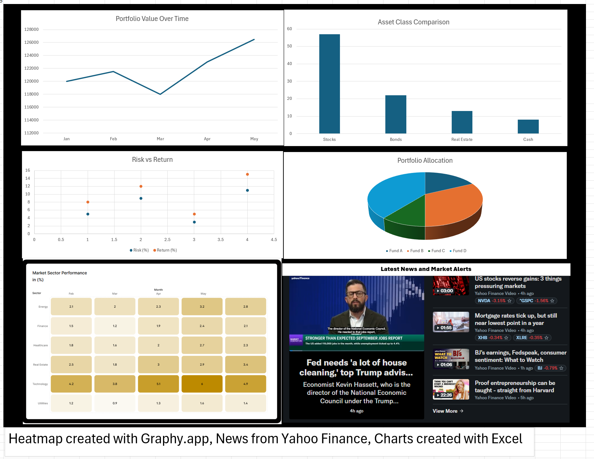
The example dashboard brings together several charts so a financial analyst can review performance and spot trends. Each chart was created from made up data specifically for the example and placed into a single view, giving the analyst a clear picture of portfolio activity, market behavior, and current news.

Top Row
- The line chart shows the portfolio’s total value from January through May. This helps the analyst check whether the account is trending upward or flattening out. Even small changes stand out when the data is shown over time.
- The bar chart compares the main asset classes in the portfolio. It shows how much is held in stocks, bonds, real estate, and cash. This lets the client see if the portfolio is leaning too heavily toward one area or if it is spread out in a balanced way.

Middle Row
- The pie chart shows portfolio allocation by fund. It gives a quick read on how money is divided among the selected investment groups. This is helpful when reviewing diversification and making sure each fund lines up with the client’s goals.
- The scatter plot displays risk and return for each investment. Items with higher returns but higher risk stand apart from lower-risk holdings. The analyst can use this to decide if the mix matches the client’s comfort level or if something needs to shift.

Bottom Row
- The heatmap shows market sector performance across several months. The deeper colors highlight stronger months for a sector, while lighter colors show weaker periods. This makes patterns easier to see, such as improving or declining momentum in a sector.
- The news panel pulls recent financial headlines. This adds helpful context, since economic reports, rate changes, or major company news can affect market behavior. Placing this next to the charts gives the team a fuller picture when reviewing performance.
Together, these visuals form a complete dashboard that supports faster decisions and clearer communication with clients.

Conclusion
Clear data visualization supports informed financial decisions and strengthens communication between advisors and clients. Using tools like Power BI, Tableau, and public financial data sources can help your firm provide accurate market insight and portfolio performance updates without slowing down the analysis process. A well designed dashboard turns complex financial activity into something clients can follow and trust.

References

Oh, A. (2019, March 7). How to build your financial dashboard: A step-by-step guide. ClearPoint Strategy. https://www.clearpointstrategy.com/blog/financial-dashboard
Tableau. (n.d.). Data visualization tips and best practices. https://www.tableau.com/visualization/data-visualization-best-practices Tableau
Merrefield, C. (2025, January 6). If you report on the U.S. economy, get to know these 8 data sources. The Journalist’s Resource. https://journalistsresource.org/economics/economic-data-sources/
F9 Finance. (2024, June). My ultimate guide to finance dashboard design best practices. https://www.f9finance.com/dashboard-design-best-practices/
AJELIX. (2024) “Financial data visualization examples and best practices.” https://ajelix.com/data/financial-data-visualization-examples/
“8 best practices for dashboard design with excellent examples.” (2024, May). Sigma Computing Blog. https://www.sigmacomputing.com/blog/best-practices-dashboard-design-examples
Federal Reserve Bank of St. Louis. (n.d.). FRED®: Economic data. https://fred.stlouisfed.org/
U.S. Bureau of Economic Analysis. (n.d.). Economic and financial data sets. https://www.bea.gov/

